Løsningsforslag - Eksamen TMM4230 Teknologi for IO og semsntisk web, 2009

1 .NET

1.1
c)

1.2
Class Reference
Struct Value
int Value
String Reference
bool Value
Interface Reference

1.3
///<summary>
///Prints the given text to the console.
///</summary>
///<param name=”text”>The text to print to the console.</param>
Note:
- Any sensible description within the <summary> and </summary> and <param name=”text”> and </param> is accepted.
- Line breaks are not important. For example, <summary>….</summary> or <param name=”text”> and </param> on the same line is OK.
- All lines need to start with ///
- “text” without quotes (<param name=text>) is also fine.
- No text outside <summary>….</summary> or <param name=”text”> … </param>

1.4
a), d), f)

1.5
b)

1.6
f)

1.7
MSIL, or Microsoft Intermediate Language. Just “Intermediate Language” or “IL” is also accepted.

1.8
a)

1.9
b)

1.10
g)

1.11
A6, B4, C1, D2, E5, F3

2. WCF

2.1
f)

2.2
c)

2.3
[ServiceContract]
public interface IGreetingService
{
[OperationContract]
string GetGreeting(Person person);
}

[DataContract]
public class Person
{
[DataMember]
public string FirstName { get; set; }
[DataMember]
public string LastName { get; set; }
}
Note:
- Wrapping namespace Greetings { <YOUR CODE> } around all or parts of the code is OK.
- Line breaks indentation are not important, ie. this is also valid (example):
[DataContract] public class Person {
[DataMember] public string FirstName { get; set; }
[DataMember] public string FirstName { get; set; }
}
- Sequence is not important; Person can be before IGreetingService and LastName before FirstName.
- NO public before string GetGreeting(Person person);

2.4
a)

2.5
d)

2.6
c)

2.7
1 private void btnAsk_Click(object sender, EventArgs e)
2 {
3 BussServiceClient client = new BussServiceClient();
4 string question = txtQuestion.Text;
5 string answer = client.AskQuestion(question);
6 txtAnswer.Text = answer;
7 }

5 string answer = client.AskQuestion(txtQuestion.Text);
and blank or “” or anything else that compiles on line 4 is also OK, since it would give the same result.

2.8
b), e), f), i)

3. WF

3.1
Sequential workflow

3.2
a)

3.3
d)

3.4
b), c), e), f), i) , j)

3.5
a)

3.6
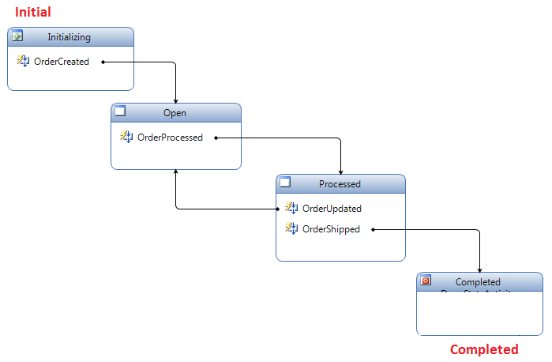
Note:
- The sketch does not need to look exactly like the figure above, but it needs to illustrate the same concept. Arrows must go from and to the correct states and originate from the correct event name (ie. OrderCreated, OrderProcessed etc). Initial and Completed needs to be indicated (can also be indicated by the small green and red icon in the Initializing/Completed states).

4. RTC

4.1
- Start line
- Headers
- Message body – (”body” is accepted)

4.2
a), b), d), f)

4.3
b)

4.4
Infrastructure Infrastruktur
Firewalls, NAT (network address translation) Brannmurer, NAT
Jitter Knitring, varians i transittid
Packet loss Pakketap
Packet Sequence Pakkerekkefølge
Echo Ekko
Security Sikkerhet

5. Intro Sem Web

5.1
a)

5.2
b)

5.3
b)

5.4
d)

6. Ontology Language

6.1
b)

6.2
b)

6.3
d)

6.4
d)

6.5
e)

6.6
b)

7. OWL Modeling

7.1
c)

7.2
a)

7.3
Administrative staff is a member of the staff that is neither faculty nor support staff.

7.4
d)

7.5
d)

7.6
With the open world assumption, anything might be true unless it can be proven false.

7.7
d)

8. Abstract OWL syntax

8.1
Old ladies are elderly female persons. All old ladies must have a pet. All old ladies can have only cats as pets. A cat owner is any person that has a cat as a pet.

8.2
b), e)

8.3
A weird student is a student that follows either TDT4215 or TDT4175 and that does not only follow courses taught at IDI.

8.4
Class: InternationalStudent
SubClassOf:
Student AND
(follows ONLY
(ErasmusProgram OR InternationalMasterProgram))

8.5
Course AND
(isTaughtBy VALUE ProfGulla) AND
(isAttendedBy SOME GoodStudent)

8.6
f)

9. OWL Modeling Primitives

9.1
b)

9.2
b)

9.3
a)

10. Ontology Engineering

10.1
d)

10.2
c)

